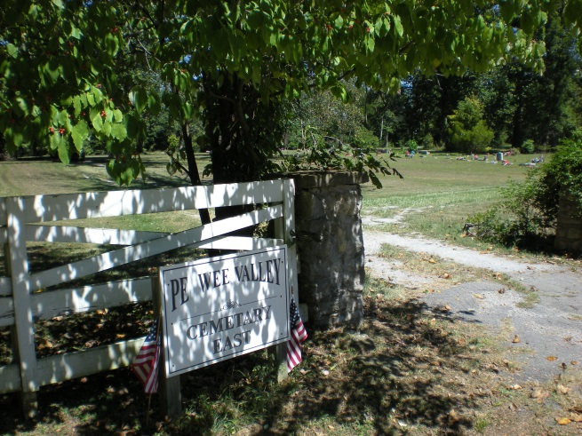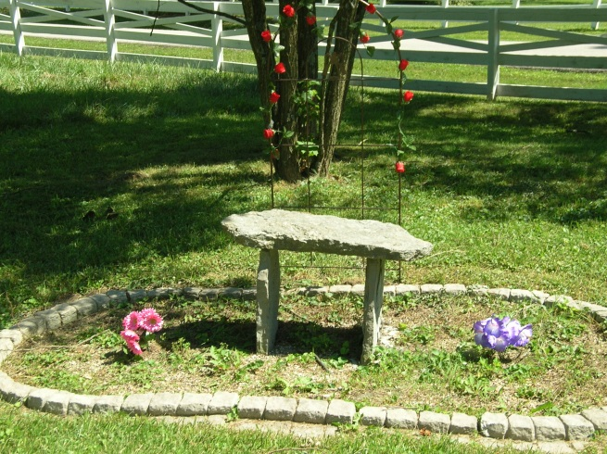
Join Us Saturday, April 26, 2014
10:00 a.m.-2:00 p.m.
Pewee Valley Cemetery East Spring Cleaning

Volunteers are needed to help clean up Pewee Valley’s historic African-American burial ground, Pewee Valley Cemetery East, on Maple Avenue across from Pewee Valley Cemetery. Students can earn community service credits for participating. So pack a lunch, put on your gardening gloves and bring your gardening tools, marked with your name. Water, treats and contractor bags for waste will be provided by the City of Pewee Valley.
Useful items to bring include:

- Rakes
- Shovels
- Clippers/pruners
- Weedeaters

Sponsored by First Baptist Church Pewee Valley
For more information, contact Walter Gales, (502) 241-8416

